Mini Project Report on

**Application of Multi-Layer Perceptrons in Hardware  
Detection of Brain Tumors from MRI Scans**



***Submitted for mini project of Digital Circuit Design laboratory as partial fulfillment of B.Tech Course***

**By:**

1. G.S. Ramanujam- 23ECB0A01  
2. B. Karthik - 23ECB0A02  
3. N. Sasank- 23ECB0A03

**Under the guidance of**

1. Dr. P. Prithvi  
2. Dr. Shuvam Pawar

**Department of Electronics and Communication Engineering**

**NITW**

Abstract: -

The early detection of brain cancer significantly influences treatment efficacy and patient survival rates. This project presents an innovative approach using Multi-Layer Perceptron (MLPs) to analyse MRI brain scans, effectively classifying them into categories with or without tumours.

Developing such systems from low level components (I.e. on FPGA boards/Basic languages such as Verilog/VHDL/SystemVerilog) helps increase the speed and decreases computation power required as well as decrease the power consumption

Contents: -

1. List of tables: -

None

1. List of figures: -

* Fig1.Multi-Layer Perceptron – Page 3
* Fig2.Relu function – Page 4
* Fig3.Nearest neighbour interpolation – Page 4

1. List of abbreviations: -

MLP -> multi-layer perceptron

SV -> SystemVerilog

FPGA -> Field Programmable Gate Array

HDL -> Hardware Description Language

VHDL ->Very High-Speed Integrated Circuit Hardware Description Language

Introduction: -

Deep learning has changed the recent era and is being used in various different fields for various types of applications (whether it be medical, research, scientific, etc etc)

This project focuses on developing a multi-layer perceptron neural network on hardware.

Building machine learning algorithms from scratch helps improve the computation efficiency and decrease power consumption.

Problem Statement: -

To develop a multi-layer perceptron in systemVerilog with a focus on medical applications

(Detection of brain tumours from MRI images)

Motivation: -

Training doctors is a costly process that requires significant resources, and India faces a shortage of medical facilities. This system aims to mitigate these challenges by providing a simple and automated solution for detecting brain tumours from MRI images.

Implementing this project using a basic hardware language such as systemVerilog not only enhances processing speed but also reduces the computational power and energy consumption required for this task.  
This project has potential in increasing the medical facilities available in our country.

Novelty: -

* Low power and low computation implementation unlike traditional implementations.
* Requires much less power and computation power due to implementation on FPGA/Basic electronic languages
* Can help junior doctors with training
* Can help give doctors a second opinion during judgement
* More accurate than traditional methods such as histogram generation etc.

Objectives: -

* To design and implement a low power, low computation required multi-layer perceptron with other extra features for the specific problem statement.
* To get a highly accurate implementation which can aid medical industry in various ways (Such as the ones mentioned before (i.e. helping junior doctors, getting second opinion etc))

Theory: -

* **Multi-Layer perceptron**: -

Multi-layer perceptrons are feed forward neural networks containing generally 3 or more layers.

They are fully connected in nature (i.e. each node in previous layer is connected to every other node in the next later)

Each node in multi-layer perceptron contains a value that is obtained as a summation of the activation of the nodes in the previous layer multiplied with a certain value.

Multi-layer perceptrons are the most popular type of networks used in deep learning.

Generally, non-linear functions are used in multi-layer perceptrons.

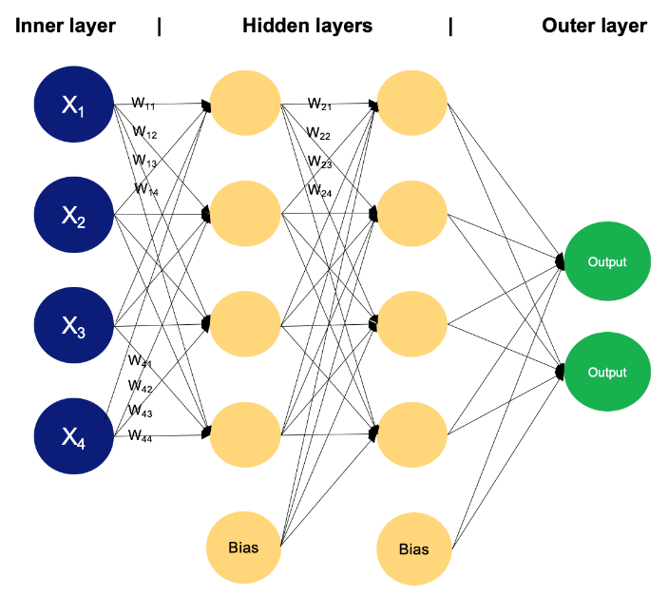Multi-layer perceptrons can be trained mathematically via back propagation.

Fig1.Multi-Layer perceptron

Source: -DataCamp

* **Activation functions**: -

An activation function is a function in a neural network that calculates the outputs based on the input.   
Generally, ReLU is used as the activation function for MLPs.

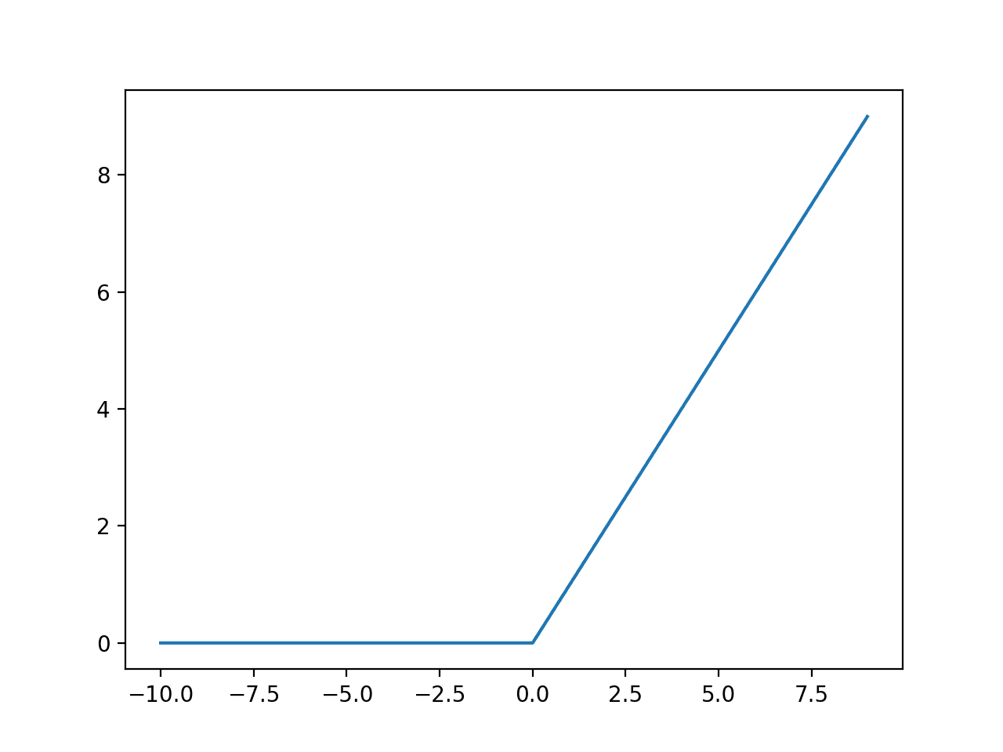Fig2.ReLU function

(Source: - Machine learning Mastery)

* **Feature map generation**: -

Feature map (also called activation map) is the output array of images generated when an array of kernels/filters is passed over the original image.

Feature maps help highlight various elements of the image such as edges, diagonals, lights and shadows, certain shapes etc.  
In our application, ideally, the generated kernels for the feature map will be able to determine the shape of various types of brain tumours.

* **Nearest neighbour interpolation**: -

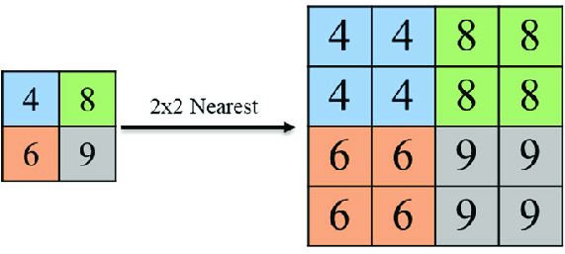To put simply, Nearest neighbour interpolation is an image resize technique. It works by finding the position of the nearest neighbouring pixel and setting the intensity value of the image to be scaled to that value.

Fig3.Nearest neighbour interpolation

(Source: - ResearchGate)

Workflow: -

1. Take MRI scan images.
2. Resize the images (By applying nearest neighbour interpolation).
3. Apply convolution and generate feature map. (optional)
4. Pass the feature map/image through multi-layer perceptron.
5. Apply SoftMax function on the output to calculate probability of different types of cancer from the image.
6. Give the output to the user.

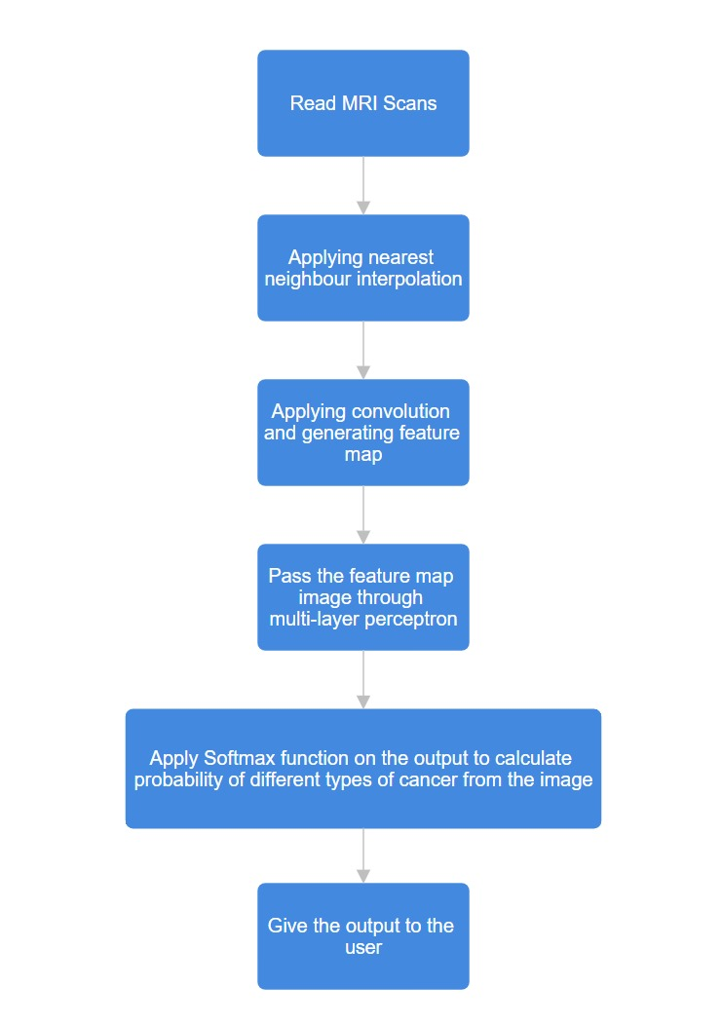

Source codes :-

1.Class implementations :-

`timescale 1ns / 1ps

//////////////////////////////////////////////////////////////////////////////////

// Company:

// Engineer:

//

// Create Date: 11/02/2024 11:46:17 AM

// Design Name:

// Module Name: main

// Project Name:

// Target Devices:

// Tool Versions:

// Description:

//

// Dependencies:

//

// Revision:

// Revision 0.01 - File Created

// Additional Comments:

//

//////////////////////////////////////////////////////////////////////////////////

class Conv2D;

integer inputHeight, inputWidth;

integer kernelHeight, kernelWidth;

integer stride;

integer outputHeight, outputWidth;

real inputMat[][];

real kernel[][];

real outputMat[][];

function new(input integer inputHeight, input integer inputWidth,

input integer kernelHeight, input integer kernelWidth,

input integer stride);

this.inputHeight = inputHeight;

this.inputWidth = inputWidth;

this.kernelHeight = kernelHeight;

this.kernelWidth = kernelWidth;

this.stride = stride;

this.outputHeight = (inputHeight - kernelHeight) / stride + 1;

this.outputWidth = (inputWidth - kernelWidth) / stride + 1;

this.inputMat = new[inputHeight];

for (int i = 0; i < inputHeight; i++) begin

this.inputMat[i] = new[inputWidth];

end

this.kernel = new[kernelHeight];

for (int i = 0; i < kernelHeight; i++) begin

this.kernel[i] = new[kernelWidth];

end

this.outputMat = new[outputHeight];

for (int i = 0; i < outputHeight; i++) begin

this.outputMat[i] = new[outputWidth];

end

endfunction

function void setInputAndKernel(input real inputMat[][], input real kernel[][]);

//$display("Setting conv weights");

for (int i = 0; i < inputHeight; i++) begin

for (int j = 0; j < inputWidth; j++) begin

this.inputMat[i][j] = inputMat[i][j];

end

end

for (int i = 0; i < kernelHeight; i++) begin

for (int j = 0; j < kernelWidth; j++) begin

this.kernel[i][j] = kernel[i][j];

end

end

endfunction

function void applyConvolution();

real sum;

//$display("Applying 2D conv");

for (int i = 0; i < outputHeight; i++) begin

for (int j = 0; j < outputWidth; j++) begin

sum = 0;

for (int ki = 0; ki < kernelHeight; ki++) begin

for (int kj = 0; kj < kernelWidth; kj++) begin

sum += inputMat[i * stride + ki][j * stride + kj] * kernel[ki][kj];

end

end

outputMat[i][j] = sum;

end

end

endfunction

function void displayOutput();

$display("Output Matrix:");

for (int i = 0; i < outputHeight; i++) begin

for (int j = 0; j < outputWidth; j++) begin

$write("%0.2f ", outputMat[i][j]);

end

$display("");

end

endfunction

endclass

class featureMapGen;

integer noOfKernels;

integer inputHeight, inputWidth;

integer kernelHeight, kernelWidth;

integer stride;

real inputMat[][];

real kernel[][][];

real outputMat[][][];

integer outputWidth, outputHeight;

function new(input integer inputHeight, input integer inputWidth,

input integer kernelHeight, input integer kernelWidth,

input integer stride, input integer noOfKernels);

this.inputHeight = inputHeight;

this.inputWidth = inputWidth;

this.kernelHeight = kernelHeight;

this.kernelWidth = kernelWidth;

this.stride = stride;

this.outputHeight = (inputHeight - kernelHeight) / stride + 1;

this.outputWidth = (inputWidth - kernelWidth) / stride + 1;

this.noOfKernels = noOfKernels;

this.inputMat = new[inputHeight];

for (int i = 0; i < inputHeight; i++) begin

this.inputMat[i] = new[inputWidth];

end

this.kernel = new[noOfKernels];

for (int k = 0; k < noOfKernels; k++) begin

this.kernel[k] = new[kernelHeight];

for (int i = 0; i < kernelHeight; i++) begin

this.kernel[k][i] = new[kernelWidth];

end

end

this.outputMat = new [noOfKernels];

for (int k = 0; k < noOfKernels; k++) begin

this.outputMat[k] = new[outputHeight];

for (int i = 0; i < outputHeight; i++) begin

this.outputMat[k][i] = new[outputWidth];

end

end

endfunction

function void setInputAndKernel(input real inputMat[][], input real kernel[][][]);

//$display("Setting 3d weights");

for (int i = 0; i < inputHeight; i++) begin

for (int j = 0; j < inputWidth; j++) begin

this.inputMat[i][j] = inputMat[i][j];

end

end

for(int k = 0; k < noOfKernels ; k++) begin

for (int i = 0; i < kernelHeight; i++) begin

for (int j = 0; j < kernelWidth; j++) begin

this.kernel[k][i][j] = kernel[k][i][j];

end

end

end

endfunction

function void setOut(input integer k , input real o[][]);

// $display("Size of outputmat:");

// $display($size(outputMat));

// $display($size(outputMat[0]));

// $display($size(outputMat[0][0]));

for(int i = 0; i < outputHeight ; i ++) begin

for (int j =0 ; j < outputWidth ; j ++) begin

//$display("%0.2f ", o[i][j]);

this.outputMat[k][i][j] = o[i][j];

end

end

endfunction;

function void apply();

for(int k = 0; k < noOfKernels ; k++) begin

Conv2D conv = new(inputHeight, inputWidth, kernelHeight, kernelWidth, stride);

conv.setInputAndKernel(this.inputMat, this.kernel[k]);

conv.applyConvolution();

//$write("%0.2f ", inputMat[0][0]);

// conv.displayOutput();

setOut(k,conv.outputMat);

end

endfunction

function void displayOutput(input integer k);

$display("Output Matrix:");

for (int i = 0; i < outputHeight; i++) begin

for (int j = 0; j < outputWidth; j++) begin

$write("%0.31f ", outputMat[k][i][j]);

end

$display("");

end

endfunction

endclass

class max_pooling;

integer poolSize;

integer noOfInputLayers;

integer inputHeight, inputWidth;

real inputMat[][][];

real outputMat[][][];

integer outputWidth, outputHeight;

function new(input integer inputHeight, input integer inputWidth,

input integer poolSize, input integer noOfInputLayers);

this.inputHeight = inputHeight;

this.inputWidth = inputWidth;

this.poolSize = poolSize;

this.noOfInputLayers = noOfInputLayers;

this.outputWidth = inputWidth / poolSize;

this.outputHeight = inputHeight / poolSize;

this.inputMat = new[noOfInputLayers];

this.outputMat = new[noOfInputLayers];

for (int k = 0; k < noOfInputLayers; k++) begin

this.inputMat[k] = new[inputHeight];

this.outputMat[k] = new[outputHeight];

for (int i = 0; i < inputHeight; i++) begin

this.inputMat[k][i] = new[inputWidth];

end

for (int i = 0; i < outputHeight; i++) begin

this.outputMat[k][i] = new[outputWidth];

end

end

endfunction

function void setInput(input real inputMat[][][]);

for(int i = 0; i < noOfInputLayers; i++) begin

for(int j = 0; j < inputHeight; j++) begin

for(int k = 0; k < inputWidth; k++) begin

this.inputMat[i][j][k] = inputMat[i][j][k];

end

end

end

endfunction

function void apply();

for (int layer = 0; layer < noOfInputLayers; layer++) begin

for (int i = 0; i < outputHeight; i++) begin

for (int j = 0; j < outputWidth; j++) begin

real maxVal = -1.0e30;

for (int m = 0; m < poolSize; m++) begin

for (int n = 0; n < poolSize; n++) begin

int x = i * poolSize + m;

int y = j * poolSize + n;

if (x < inputHeight && y < inputWidth) begin

maxVal = (inputMat[layer][x][y] > maxVal) ? inputMat[layer][x][y] : maxVal;

end

end

end

outputMat[layer][i][j] = maxVal;

end

end

end

endfunction

function void display();

for (int layer = 0; layer < noOfInputLayers; layer++) begin

$display("Layer %0d:", layer);

for (int i = 0; i < outputHeight; i++) begin

for (int j = 0; j < outputWidth; j++) begin

$write("%0f ", outputMat[layer][i][j]);

end

$display("");

end

$display("");

end

endfunction

endclass

class ReLu;

integer inputHeight, inputWidth;

integer noOfInputLayers;

real inputMat[][][];

real outputMat[][][];

function new(input integer inputHeight, input integer inputWidth, input integer noOfInputLayers);

this.inputHeight = inputHeight;

this.inputWidth = inputWidth;

this.noOfInputLayers = noOfInputLayers;

this.inputMat = new[noOfInputLayers];

this.outputMat = new[noOfInputLayers];

for (int k = 0; k < noOfInputLayers; k++) begin

this.inputMat[k] = new[inputHeight];

this.outputMat[k] = new[inputHeight];

for (int i = 0; i < inputHeight; i++) begin

this.inputMat[k][i] = new[inputWidth];

this.outputMat[k][i] = new[inputWidth];

end

end

endfunction

function void setInput(input real inputMat[][][]);

for(int i = 0; i < noOfInputLayers; i++) begin

for(int j = 0; j < inputHeight; j++) begin

for(int k = 0; k < inputWidth; k++) begin

this.inputMat[i][j][k] = inputMat[i][j][k];

end

end

end

endfunction

function void apply();

for (int layer = 0; layer < noOfInputLayers; layer++) begin

for (int i = 0; i < inputHeight; i++) begin

for (int j = 0; j < inputWidth; j++) begin

outputMat[layer][i][j] = (inputMat[layer][i][j] > 0) ? inputMat[layer][i][j] : 0.0;

end

end

end

endfunction

function void display();

for (int layer = 0; layer < noOfInputLayers; layer++) begin

$display("Layer %0d (ReLU Output):", layer);

for (int i = 0; i < inputHeight; i++) begin

for (int j = 0; j < inputWidth; j++) begin

$write("%0f ", outputMat[layer][i][j]);

end

$display("");

end

$display("");

end

endfunction

endclass

class Flatten;

integer inputHeight, inputWidth;

integer noOfInputLayers;

real inputMat[][][];

real outputMat[];

integer outputSize;

function new(input integer inputHeight, input integer inputWidth, input integer noOfInputLayers);

this.inputHeight = inputHeight;

this.inputWidth = inputWidth;

this.noOfInputLayers = noOfInputLayers;

this.outputSize = noOfInputLayers * inputHeight * inputWidth;

this.inputMat = new[noOfInputLayers];

this.outputMat = new[outputSize];

for (int k = 0; k < noOfInputLayers; k++) begin

this.inputMat[k] = new[inputHeight];

for (int i = 0; i < inputHeight; i++) begin

this.inputMat[k][i] = new[inputWidth];

end

end

endfunction

function void setInput(input real inputMat[][][]);

for (int i = 0; i < noOfInputLayers; i++) begin

for (int j = 0; j < inputHeight; j++) begin

for (int k = 0; k < inputWidth; k++) begin

this.inputMat[i][j][k] = inputMat[i][j][k];

end

end

end

endfunction

function void apply();

integer index = 0;

for (int layer = 0; layer < noOfInputLayers; layer++) begin

for (int i = 0; i < inputHeight; i++) begin

for (int j = 0; j < inputWidth; j++) begin

outputMat[index] = inputMat[layer][i][j];

index++;

end

end

end

endfunction

function void display();

$display("Flattened Output Vector:");

for (int i = 0; i < outputSize; i++) begin

$write("%0f ", outputMat[i]);

end

$display("");

endfunction

endclass

class layer;

integer units;

integer prevLayerUnitCount;

real weights[][];

real bias[];

real outputs[];

function new(input integer units, input integer prevLayerUnitCount);

this.units = units;

this.prevLayerUnitCount = prevLayerUnitCount;

this.weights = new[units];

for (int i = 0; i < units; i++) begin

this.weights[i] = new[prevLayerUnitCount];

end

this.bias = new[units];

this.outputs = new[units];

endfunction

function setWeights(input real weights[][], input real bias[]);

for (integer i = 0; i < units; i++) begin

for (integer j = 0; j < prevLayerUnitCount; j++) begin

this.weights[i][j] = weights[i][j];

end

end

for (integer i = 0; i < units; i++) begin

this.bias[i] = bias[i];

end

endfunction

function void forward(input real prevLayerSummations[]);

for (int i = 0; i < units; i++) begin

real sum = 0;

for (int j = 0; j < prevLayerUnitCount; j++) begin

sum += prevLayerSummations[j] * this.weights[i][j];

end

sum += this.bias[i];

this.outputs[i] = sum;

end

endfunction

function void display();

$display("NN layer output:");

for (int i = 0; i < this.units; i++) begin

$write("%0.31f ", outputs[i]);

end

$display("");

endfunction

endclass

class bias;

real inputMat [][][];

real bias [];

real outputMat[][][];

integer inputWidth,inputHeight,noOfInputLayers;

function new(input integer inputHeight, input integer inputWidth, input integer noOfInputLayers);

this.inputHeight = inputHeight;

this.inputWidth = inputWidth;

this.noOfInputLayers = noOfInputLayers;

this.inputMat = new[noOfInputLayers];

this.outputMat = new[noOfInputLayers];

this.bias = new[noOfInputLayers];

for (int k = 0; k < noOfInputLayers; k++) begin

this.inputMat[k] = new[inputHeight];

this.outputMat[k] = new [inputHeight];

for (int i = 0; i < inputHeight; i++) begin

this.inputMat[k][i] = new[inputWidth];

this.outputMat[k][i] = new [inputWidth];

end

end

endfunction

function void setInputAndBias(input real inputMat[][][] , input real bias[]);

for (int i = 0; i < noOfInputLayers; i++) begin

for (int j = 0; j < inputHeight; j++) begin

for (int k = 0; k < inputWidth; k++) begin

this.inputMat[i][j][k] = inputMat[i][j][k];

end

end

end

for(int i = 0 ; i < noOfInputLayers ; i ++ ) begin

this.bias[i] = bias[i];

end

endfunction

function void apply();

for(int i = 0 ; i < noOfInputLayers ; i ++ ) begin

for( int j = 0 ; j < inputHeight ; j ++ )begin

for(int k = 0 ; k < inputWidth ; k++) begin

this.outputMat[i][j][k] = this.inputMat[i][j][k] + this.bias[i];

end

end

end

endfunction

endclass

class ReLu1D;

real size;

real outputs[];

function new(input integer size);

this.size = size;

this.outputs = new[size];

endfunction

function void apply(input real inputArr[]);

for (int j = 0; j < this.size; j++) begin

this.outputs[j] = (inputArr[j] > 0) ? inputArr[j] : 0.0;

end

endfunction

endclass

class softmax;

real size;

real outputs[];

function new(input integer size);

this.size = size;

this.outputs = new[size];

endfunction

function void apply(input real inputArr[]);

real total;

total = 0;

for (int j = 0; j < this.size; j++) begin

total = total + $exp(inputArr[j]);

end

for (int j = 0; j < this.size; j++) begin

this.outputs[j] = $exp(inputArr[j])/total;

end

endfunction

function void display();

$display("Softmax layer output:");

for (int i = 0; i < this.size; i++) begin

$write("%0.31f ", this.outputs[i] * 100,"percent");

end

$display("");

endfunction

endclass

class resizer;

int originalM;

int originalN;

int m;

int n;

real resizedImage[][];

real image[][];

real mScale;

real nScale;

function new(input real image[][], input int m, input int n);

this.originalM = $size(image,1);

this.originalN = $size(image,2);

this.m = m;

this.n = n;

this.resizedImage = new[m];

for (int i = 0; i < m; i++) begin

this.resizedImage[i] = new[n];

end

this.image = new[this.originalM];

for (int i = 0; i < this.originalM; i++) begin

this.image[i] = new[this.originalN];

end

for (int i = 0; i < this.originalM; i = i+1) begin

for (int j = 0; j < this.originalN; j = j+1) begin

this.image[i][j] = image[i][j];

end

end

this.mScale = real'(this.originalM) / real'(m);

this.nScale = real'(this.originalN) / real'(n);

endfunction

function void resizeImage();

int xAxis;

int yAxis;

for (int i = 0; i < this.m; i = i+1) begin

for (int j = 0; j < this.n; j = j+1) begin

xAxis = int'(i * this.mScale);

yAxis = int'(j * this.nScale);

this.resizedImage[i][j] = this.image[xAxis][yAxis];

end

end

endfunction

endclass

2.Main Module code (Without weights):-

module brainTumorMLP(

input real sampleInput[][],

input wire clk,

output real outputs[4]

);

resizer myResizer;

featureMapGen conv1 = new(64,64,3,3,1,4);

bias b = new(62,62,4);

ReLu relu1 = new(62,62,4);

max_pooling mp = new(62, 62, 8, 4);

Flatten flatten = new(7, 7, 4);

layer fc1= new(64,196);

ReLu1D relu2 = new(64);

layer fc2 = new(4,64);

softmax softmax1 = new(4);

real convWeights [4][3][3] = '{'{'{0.1172003373503685,-0.03289278969168663,0.12456241250038147},'{0.11300346255302429,-0.06019530072808266,-0.04897616058588028},'{-0.10059317946434021,0.12360098958015442,-0.12589161098003387}},……}}};

real convBias [4]='{-0.24905812740325928,-0.1010550931096077,0.6269946098327637,-1.0818099975585938};

real fc1Weights[64][196] = '{'{-0.07034479826688766,0.06950978189706802,0.011454099789261818,0.06969571858644485,0.018239900469779968,-0.058077238500118256,0.0025969198904931545,-0.019098790362477303,-0.006723769940435886,…..}};

real fc1bias[64] = '{-0.03151005879044533,-0.0066734799183905125,0.2213207632303238,0.019091419875621796,0.0684792771935463,0.13682948052883148,-0.007645280100405216,0…… };

real fc2weights[4][64] = '{'{1.2677628993988037,0.07919859886169434,0.16367317736148834,-1.7694803476333618,-0.19354772567749023,0.2778038084506988…..}};

real fc2bias[4] = '{-0.0610617995262146,-0.1329321265220642,0.010950460098683834,0.31129783391952515};

always @(posedge clk) begin

myResizer = new(sampleInput, 64, 64);

myResizer.resizeImage();

conv1.setInputAndKernel(myResizer.resizedImage,convWeights);

conv1.apply();

//conv1.displayOutput(0);

//$display("=== Bias Test ===");

b.setInputAndBias(conv1.outputMat,convBias);

b.apply();

//$display("=== ReLU Activation Test ===");

relu1.setInput(b.outputMat);

relu1.apply();

//relu1.display();

//$display("=== Max Pooling Test ===");

mp.setInput(relu1.outputMat);

mp.apply();

//mp.display();

//$display("=== Flattening Test ===");

flatten.setInput(mp.outputMat);

flatten.apply();

//flatten.display();

//$display("=== Linear layer 1===");

fc1.setWeights(fc1Weights,fc1bias);

fc1.forward(flatten.outputMat);

//fc1.display();

// $display("Relu 2");

relu2.apply(fc1.outputs);

//$display("=== Linear layer 2===");

fc2.setWeights(fc2weights,fc2bias);

fc2.forward(relu2.outputs);

//fc2.display();

//$display("=== Softmax layer ===");

softmax1.apply(fc2.outputs);

outputs = softmax1.outputs;

//softmax1.display();

end

endmodule

3.Testbench code:-

`timescale 1ns / 1ps

//////////////////////////////////////////////////////////////////////////////////

// Company:

// Engineer:

//

// Create Date: 11/02/2024 11:51:40 AM

// Design Name:

// Module Name: testbench

// Project Name:

// Target Devices:

// Tool Versions:

// Description:

//

// Dependencies:

//

// Revision:

// Revision 0.01 - File Created

// Additional Comments:

//

//////////////////////////////////////////////////////////////////////////////////

module testbench();

//no tumor - 0, glioma - 1, menin - 2, pituitary - 3

real sampleInput[64][64];

real outputs[4];

reg clk;

brainTumorMLP mymodel (

.sampleInput(sampleInput),

.clk(clk),

.outputs(outputs)

);

initial begin

//Case 1 :- Glioma

clk = 0;#5;

clk = 1;

sampleInput= '{'{0.0000, 0.0000, 0.0000, 0.0000, 0.0000, 0.0000, 0.0000, 0.00....};

#10;

$display("No tumor : ",outputs[0] * 100," percent");

$display("Glioma tumor: ",outputs[1] * 100," percent");

$display("Meningioma tumor : ",outputs[2] * 100," percent");

$display("Pituitary : ",outputs[3] * 100," percent");

//Case 2 :- meningioma

clk = 0;#5;

clk = 1;

sampleInput= '{'{0.3451, 0.2588, 0.2588, 0.2588, 0.2588, 0.2588....};

#10;

$display("No tumor : ",outputs[0] * 100," percent");

$display("Glioma tumor: ",outputs[1] * 100," percent");

$display("Meningioma tumor : ",outputs[2] * 100," percent");

$display("Pituitary : ",outputs[3] * 100," percent");

//Case 3 :- no tumor

clk = 0;#5;

clk = 1;

sampleInput= '{'{0.0000, 0.0000, 0.0000, 0.0000, 0.0000, 0.0078, 0.0118, 0.0078, 0.01....};

#10;

$display("No tumor : ",outputs[0] * 100," percent");

$display("Glioma tumor: ",outputs[1] * 100," percent");

$display("Meningioma tumor : ",outputs[2] * 100," percent");

$display("Pituitary : ",outputs[3] * 100," percent");

//Case 4 :- pituitary

clk = 0;#5;

clk = 1;

sampleInput= '{'{0.3451, 0.2588, 0.2588, 0.2588, 0.2588, 0.2588, 0.2588, 0.258...};

#10;

$display("No tumor : ",outputs[0] * 100," percent");

$display("Glioma tumor: ",outputs[1] * 100," percent");

$display("Meningioma tumor : ",outputs[2] * 100," percent");

$display("Pituitary : ",outputs[3] * 100," percent");

$finish;

end

endmodule

Output results :-

At each posedge, we see the probability of a certain type of cancer in the input image on the TCL console and the simulation output window

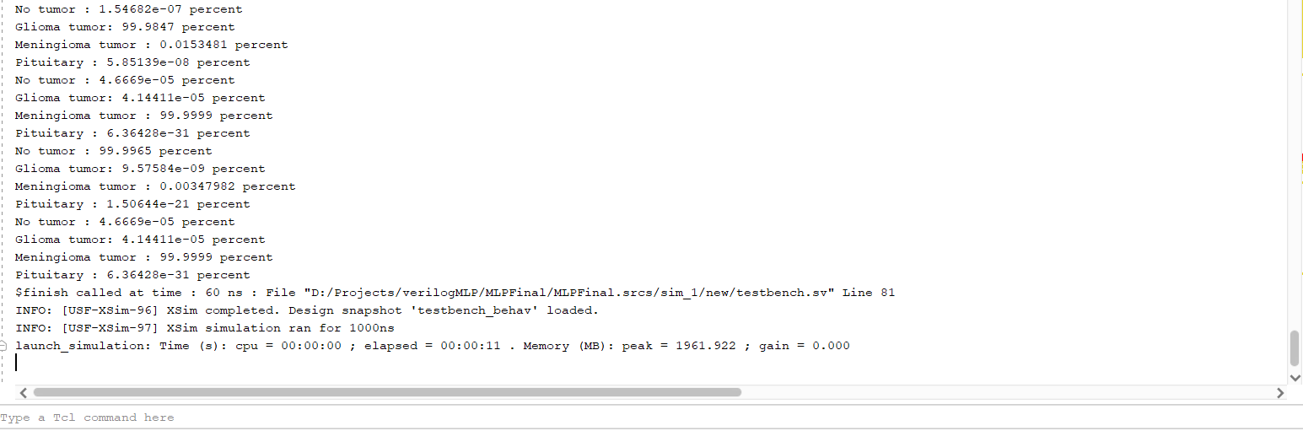

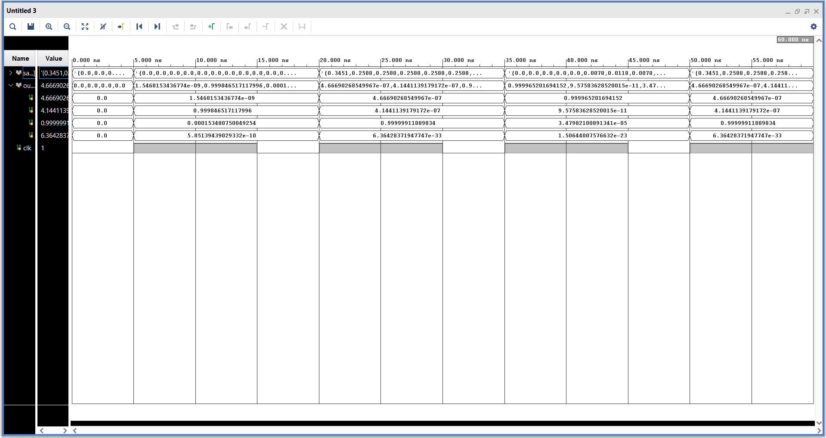

Results and conclusions: -

* Reached moderately high accuracy in detecting type of cancer from MRI image.
* Reached very high accuracy in determining whether the person has cancer or not from the MRI image
* Unlike traditional methods which have a fixed accuracy, the accuracy of this system will increase as it gets more and more data over time.

References: -

* Neural networks and deep learning from 3Blue1Brown

<https://youtu.be/aircAruvnKk?feature=shared>

* System Verilog reference from chipVerify

https://www.chipverify.com/tutorials/systemverilog

* Mathematical algorithm inspiration etc from pyTorch documentation  
  <https://pytorch.org/docs/stable/index.html>
* Nearest neighbour interpolation from Wikipedia

https://en.wikipedia.org/wiki/Nearest-neighbor_interpolation